To avoid that this code is shown you can use the following R code:

knitr::opts\_chunk$set(echo=FALSE, warning=FALSE, message=FALSE)

In addition, you can see the R Markdown Reference Guide [here](https://www.rstudio.com/wp-content/uploads/2015/03/rmarkdown-reference.pdf).

This [link](http://www.engineeringintro.com/statistics/introduction-statistics/univariate-bivariate-and-multivariate-data/) explain a little more how to classify each analysis. The image below can resume it:

[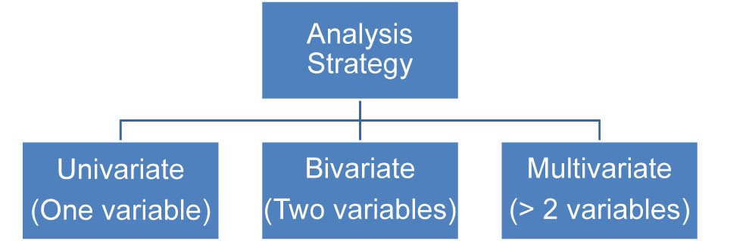](https://udacity-reviews-uploads.s3.us-west-2.amazonaws.com/_attachments/48035/1534981858/analises.jpg)

I would like to recommend you to know the project [from Data to Viz](https://www.data-to-viz.com/) that is an excellent resource to help us to choose the better visualization for our data using interactive flux and decision trees.  
See below Data to Viz poster displaying the decision trees:

[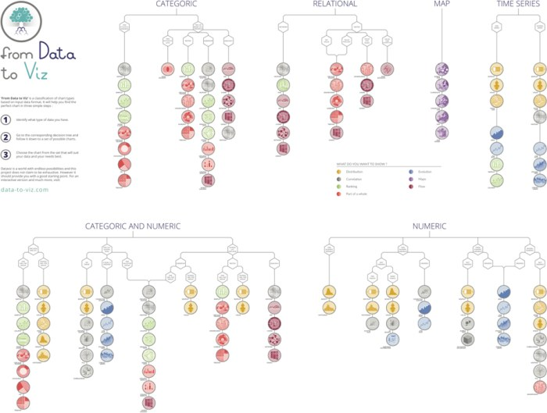](https://udacity-reviews-uploads.s3.us-west-2.amazonaws.com/_attachments/48035/1534203127/dataviz-fig1-700.jpg)

It is very difficult to see the relevant correlations without colors and with subtitles cut. Create a view that allows more immediate interpretation. See in this [link](http://www.sthda.com/english/wiki/visualize-correlation-matrix-using-correlogram" \t "_blank)interesting examples of visualization of correlations and sample codes in R.  
See how this visualization makes easier the interpretation:

http://www.sthda.com/english/wiki/visualize-correlation-matrix-using-correlogram  
[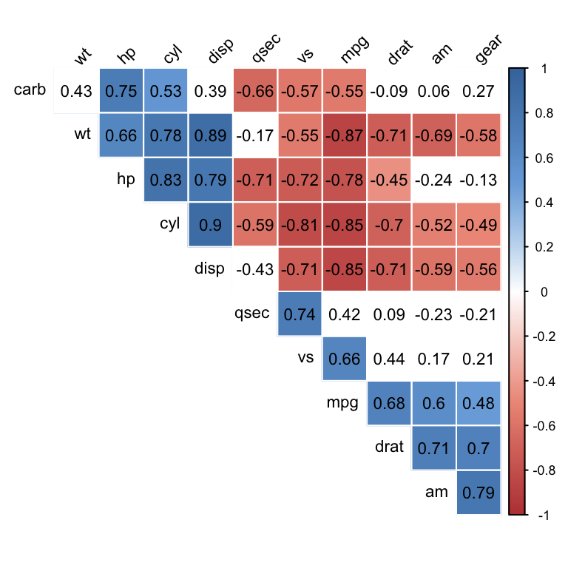](https://udacity-reviews-uploads.s3.us-west-2.amazonaws.com/_attachments/48035/1530136188/visualize-correlation-matrix-using-correlogram-customize-correlogram.png)

We should avoid using the colors **green** and **red** together because colorblind people will have difficulty analyzing the graph. See this article on this:

<https://www.tableau.com/about/blog/2016/4/examining-data-viz-rules-dont-use-red-green-together-53463>